Birmingham Choice

Bidding Guidance

Table of Contents
Bidding Guidance 3
STEP 1 4
Login to your account 4
Mobility 4
STEP 2 5
How to bid 5
STEP 3 10
Apply For Property 10
STEP 4 11
Place A Bid 11
STEP 5 11
My Active Bids 11
STEP 6 12
Withdrawing a bid 12
STEP 7 14
What happens to my bid if it is not withdrawn? 14
What is a direct offer? 14

Bidding Guidance
Once your application has been accepted and is "active" you can start bidding for properties.
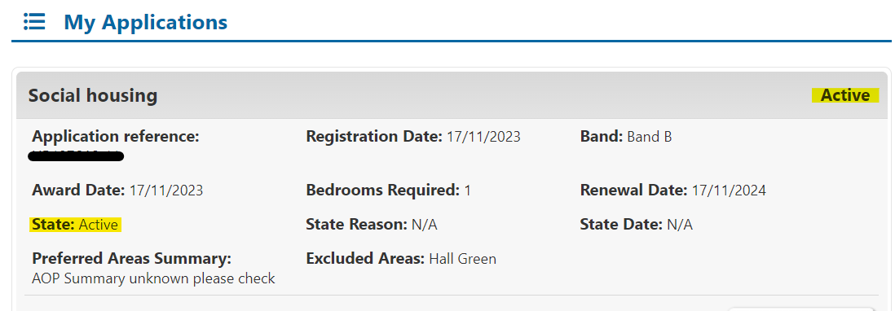
Bidding allows you and other people on the housing register to express an interest in properties advertised by Birmingham City Council and some Housing Associations.
Properties that are available to bid on are advertised on a weekly cycle starting from midnight on Thursday mornings and ending the following Monday at 11:59pm. (Bidding cycles may vary during bank holidays.)
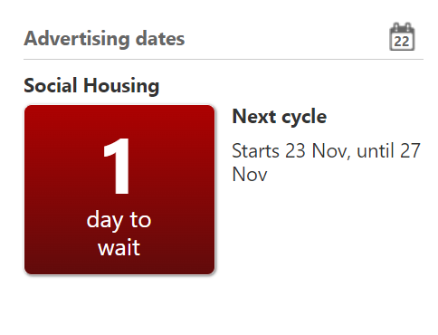
Your band award and award and registration date will determine how successful you are.

STEP 1

Login to your account
Login to your account to view the properties you are eligible to bid for. You will see the ‘Login’ button at the top right of www.birminghamchoice.co.uk
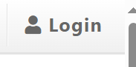
You can place 2 bids during each bidding cycle. Bids can be reviewed and changed before the bidding cycle closes at midnight every Monday. This means that if you place a bid early in the bidding cycle, at which point you are in bid position 1 but when you check again a few days later you find that there are a lot of people ahead of you, then you can remove the bid and use it on a different property. As a rough guide, only the top one, two or three bids are invited to a viewing. Occasionally people below this may be invited the following week if no-one accepts the property.
Clicking on each property listing will tell you more about it, including the landlord, location, size, rent and other features.

Mobility
Applicants accepted onto the housing register who have, or household member has, a physical disability and requires a property with adaptations are assessed by an Occupational Therapist. To ensure the best match to available adapted properties, the applicant’s level of adaptations is identified and a mobility category of “Mobility” 1, 2 or 3 will be given based upon the level of need. This category of need will be confirmed by the Occupational Therapist directly to you and to the Applications and Allocations Team.
For example, a mobility 2 category may be awarded to a person who needs a level access shower and level access to a property.
To make best use of the housing stock and ensure people can be easily matched; when adapted properties become available for re-letting the properties are advertised by categorising the mobility level and matching the characteristics of any adaptations. Adapted properties are not necessarily wheelchair accessible – levels of adaptations vary from property to property.
The categories of the adaptations will include at least one of the following:
- Stair lift
- Through floor lift
- Level access shower or accessible bathing facilities
- Ceiling track hoist
- Wheelchair access
- Wider doorways
- Ramped or level access to an external door
- Level internal layout
Each property advert contains a description of “adapted” and a set of symbols which will tell you more about the property. For example, this icon 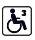identifies an adapted mobility 3 property.
This supports applicants in making an informed decision about whether a property is most suitable and to place a bid. An adapted property may not however have all the mobility facilities required by individual applicants.
Applicants who bid for a property with an adaptation, or partial adaptations, that they require will usually be prioritised over an applicant with the same priority banding who does not.
If an applicant requires adaptations and bids for a standard non adapted property, it should be suitable for their needs or suitable to be adapted. The usual shortlisting rules will apply.
If the property is accepted, tenants may then apply for adaptations to be installed with assistance and permission of the landlord.

STEP 2

How to bid
You can check how many days are left to bid or when the next bidding cycle starts, at the bottom of the Birmingham Choice homepage:
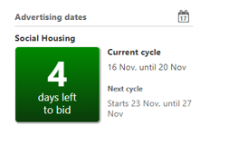
Once you have logged into your Birmingham Choice account, your account summary will tell you how many properties you are currently eligible to bid on.
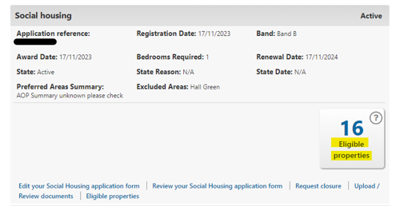
If there are no eligible properties available for you to bid on, you should check whether a bidding cycle is open.
If the cycle is open, it may be that there are no properties available that match your household’s needs.
To increase your chances of seeing eligible properties, you should consider decreasing the areas you have excluded.
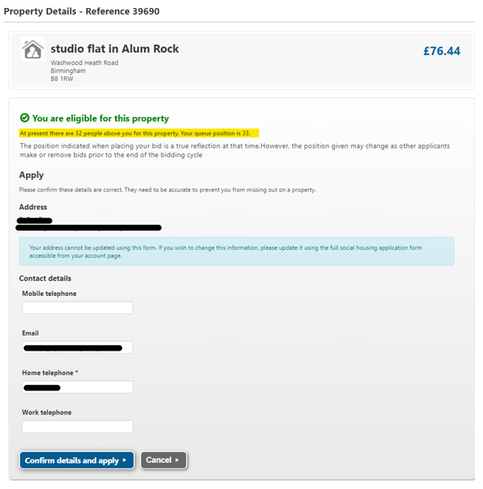
The adverts on Birmingham Choice will give you a range of information, which you can access by clicking on the tabs at the top of an advert you are looking at:
An overview of the property will be given, which includes the address, cost of rent etc including the information that relates to the icon descriptions for that advert.
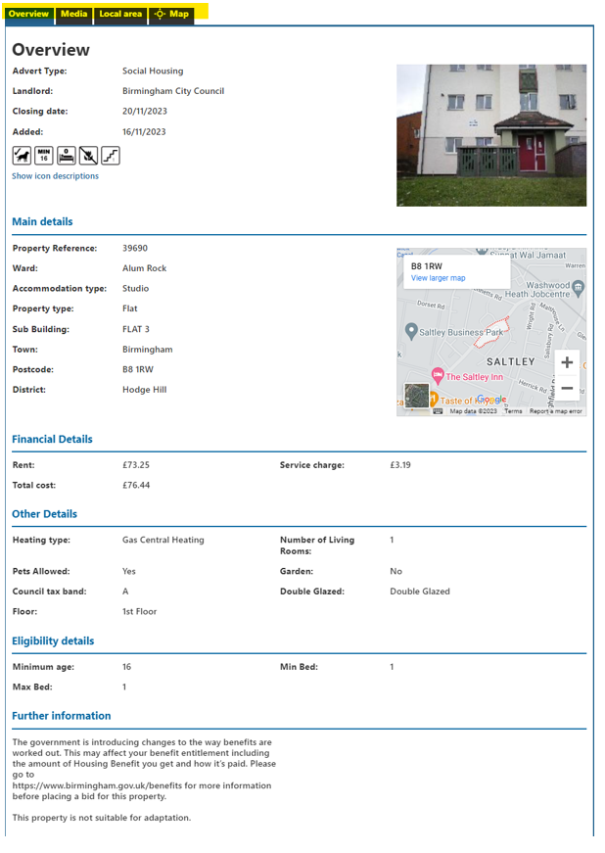

The ‘Media’ tab allows you to see any photographs for the property advert:
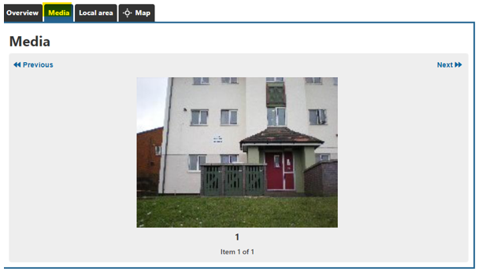
The ‘local area’ tab allows you to look at information regarding local services and Local Housing Allowance rates:
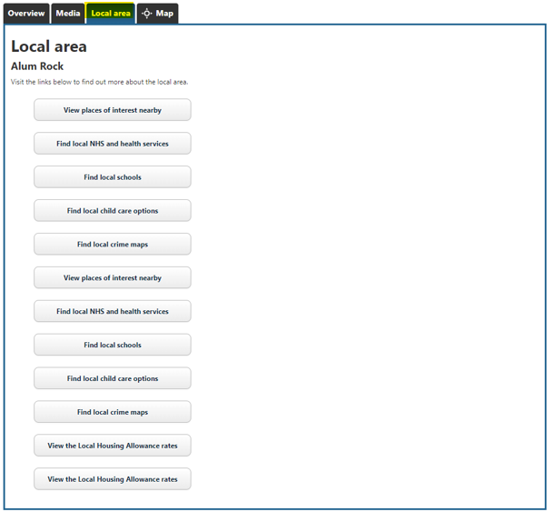
The ‘Map’ tab lets you see the location of the property on a map, and you can also click to view this on Google Maps:
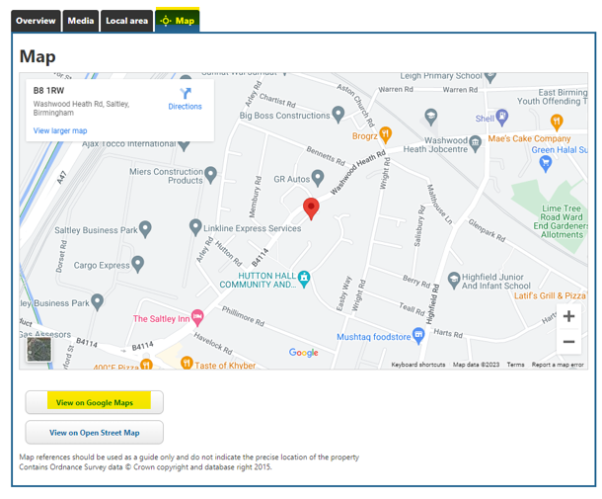

STEP 3

Apply For Property
You will see a green box that tells you that you are eligible, your predicted bid position at that time if you bid now (this can change during a bid cycle), and you have an option to apply for the property – or bid – by clicking on ‘Apply for property’:
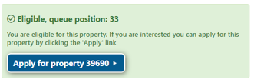
When you look at a property advert, you will be given a lot of information to consider before placing your bid. Remember, that you can place 2 bids per cycle, and you can withdraw, and place bids as needed whilst the cycle is open. You cannot withdraw a bid after the cycle has closed.

STEP 4

Place A Bid
If you want to place a bid, you will need to confirm your details. Once you have checked everything is correct, click ‘Confirm details and apply’
Once you have placed a bid for a property, you will see a message confirming the bid:
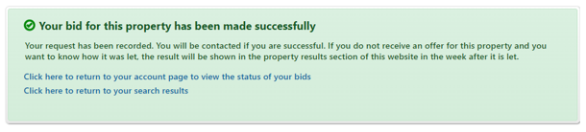

STEP 5

My Active Bids
You can view your active bids and select to view historic bids from your ‘My active bids’ section. This also shows your bidding position, when you placed the bid, and what type of bid you placed:
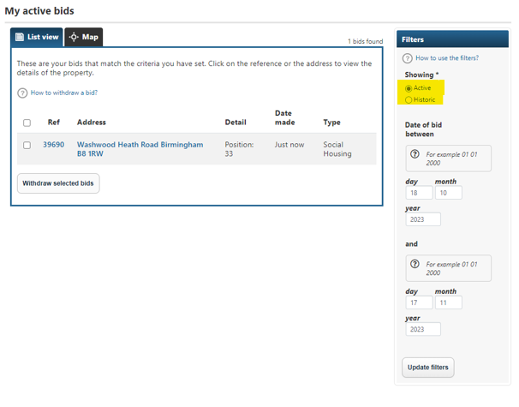

STEP 6

Withdrawing a bid
To withdraw a bid, you must complete the withdrawal process before the end of the bidding cycle on Monday evening.
You should tick the box next to the bid you want to remove and select ‘Withdraw selected bids’
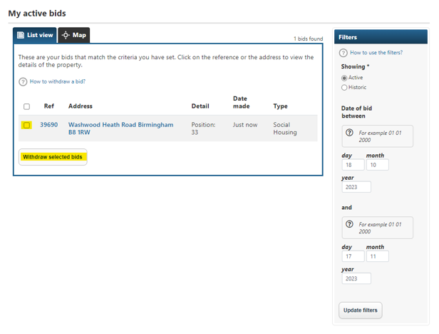
A pop up will appear asking you if you are sure you want to withdraw your bid. If you change your mind, you can place a bid on the same property again before the end of the cycle.
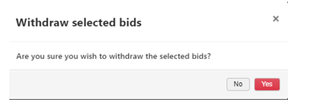

The system will then confirm that your bid has been withdrawn:
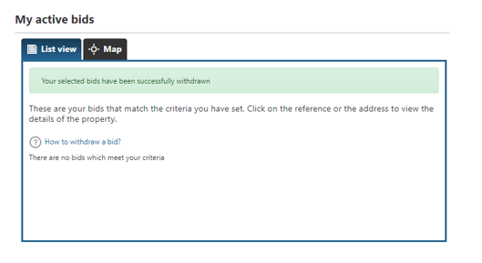

STEP 7

What happens to my bid if it is not withdrawn?
All bids on a property are automatically put in priority order (based on band and/or registration date) on the property shortlist. Once the advertising cycle has closed, the shortlist will be reviewed.
It is important to remember that your final bid position will not necessarily be your final position on the shortlist. One, two or three customers will be shortlisted and those at the top of the shortlist will normally be invited to view the property. Sometimes the shortlisting position will be different from the bid position; we will let you know if this is the case when we contact you.
If you have been overlooked (skipped) for a property, there will be a reason recorded for this, which you will be able to see when you log into your account.
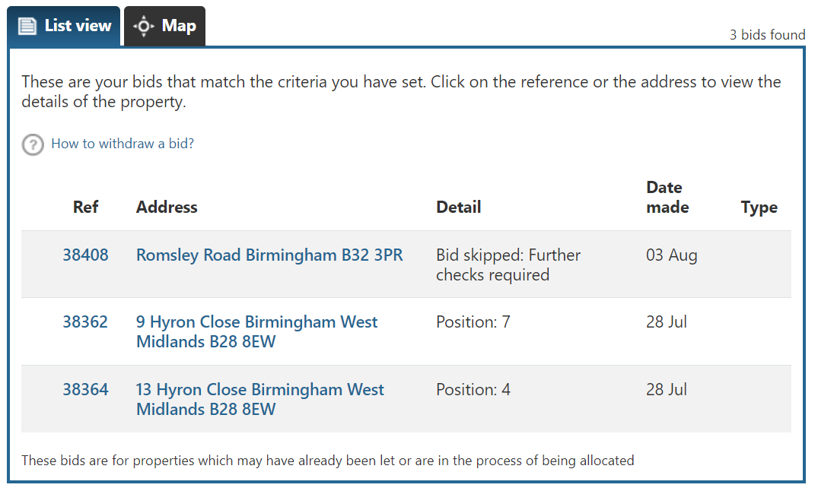

What is a direct offer?
You may notice that some of the properties listed are under direct offer. Properties under direct offer are not available to applicants to bid.
A direct offer is where the landlord has offered the property directly to an applicant without inviting applicants to bid.

