Birmingham Choice

A Guide to Online Registration

Table of Contents

Before you Register 3
How long will it take to complete the application? 3
What if I don’t have a computer? 4
Accessibility 4
Register Online 6
Step 1. 6
Step 2. 6
Step 3. 7
Step 4. 8
Step 5. 10
Step 6. 10
Step 7. 11
Step 8. 12
Step 9. 12
Step 10. 13
Applying for Social Housing 15
Section 1-3 Start an application 15
Section 4 Uploading documents 17
Section 5 Current Property Details 19
Section 6 Acceptable Behaviour 20
Section 7 Ownership/ Equity/ Assets 20
Section 8 Your Housing Need 22
Section 9 Housing Need – Supporting Information 22
Section 10 Past Addresses 23
Section 11 Preferred Areas 24
Section 12 Areas you cannot live 25
Section 13 Previous Applications 26
Section 14 Birmingham City Council Connections 27
Section 15 Application Confirmation 27
Change in circumstances for existing applicants 29

Before you Register

All applications to join Birmingham City Council’s Housing Register should be completed online at https://www.birminghamchoice.co.uk.

This applies to new applications or if you are telling us about a change in circumstances on a current application.
To be able to join the Birmingham City Council’s housing register you must be aged 16 years or over and have the right to live in the UK.
Your application will only be accepted if you are eligible and qualify to join the register.
To find out more about the Allocation Scheme and if you are likely to be eligible and qualify, you can read the full scheme document.
If you are applying for the first time, to start your application you will need:
- Full names and dates of birth for all household members
- National Insurance numbers for all household members aged 16 and over
- An email address
- A telephone number
- Current address, including postcode
- Address history, including dates, for the last 5 years
- Homeless reference number (if applicable)
- To choose a memorable date and password
- A pen and paper to note your login reference

How long will it take to complete the application?

The form should take 20 – 60 minutes to complete dependant on the number of family members in your household to be included.

You will have up to 15 minutes PER PAGE. If you run out of time you will be returned to the login page, where you should re-enter your login reference, memorable date, and password. You can then click on the link to continue your Social Housing application form. Details that you entered on the previous page will be saved, but part completed pages will not.

The application is in two parts. First you need to register your personal details and secondly, apply for social housing.

Questions marked with an asterisk* are mandatory and you will not be able to move on to the next section until you have answered them. At this point you will be asked to choose a memorable date and password. When you submit the household registration form this will create your personal account and you will be given a Login Reference number and you then can then click on the link under the Social Housing heading to complete the online housing application form.

Answer all questions that apply to you or if the question is asking for a Yes/No answer then click on the applicable one to your circumstances, then click on ‘next page’ to save your answers and move on.
When you begin your application, you will be asked questions about yourself, your household, and your housing circumstances.
If you are asked anything that you are unable to answer straight away or if you need a break, you can always save your progress and return to complete the process later.

You must provide information that is truthful and accurate. You will be asked to confirm an online declaration that you have answered the questions truthfully and have not withheld any information.

What if I don’t have a computer?
Birmingham Choice is available to use on mobile devices.
All aspects of the Birmingham Choice website including registering, uploading documents and bidding for properties can now be completed on a smart phone or tablet.
Alternatively, you could visit a library, ask a friend, relative or support worker to help you.

Accessibility
This website has various accessibility features to help you use the site:

Text only or Graphical mode
Text only mode allows you to read clutter free pages by removing unwanted content like images, you can toggle between text only and graphical mode.

Change size of text
It is possible to resize the text on this website by using the 'Normal text size', 'Large text size' and 'Extra large text size' buttons below.

Language translation
You can translate our website into 60 different languages using Google Translate.
Birmingham City Council is not responsible for the content or accuracy of external websites.

Register Online

The following section offers guidance on how to complete a housing application online to register for social housing.

The steps refer to different parts of the online form and provide guidance on how to complete the form.

Step 1.
In order to start you must first go to https://www.birminghamchoice.co.uk and select Register on the Home screen.

Step 2.
Enter your national insurance number. If you are moving with a spouse or partner, you should also input their national Insurance number as the joint applicant.

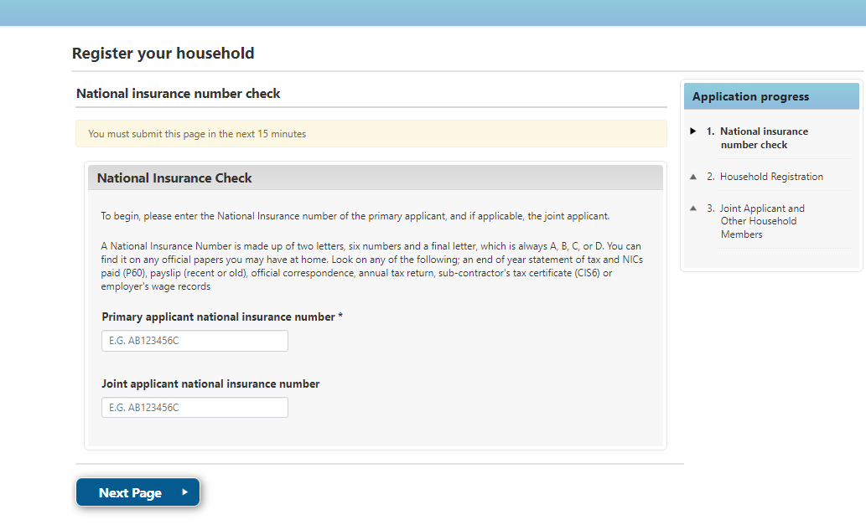

Please note that joint applicants in most cases are considered as husband/wife/partner/civil partner/fiancé living in the same property.
If you are an existing Birmingham City Council tenant applying to transfer to alternative accommodation, all tenants must be included in the application, and you will be asked to confirm if all members of your household will be moving with you.

Step 3.
Enter your name, date of birth and sex.
Remember, any question with an asterix* must be completed.

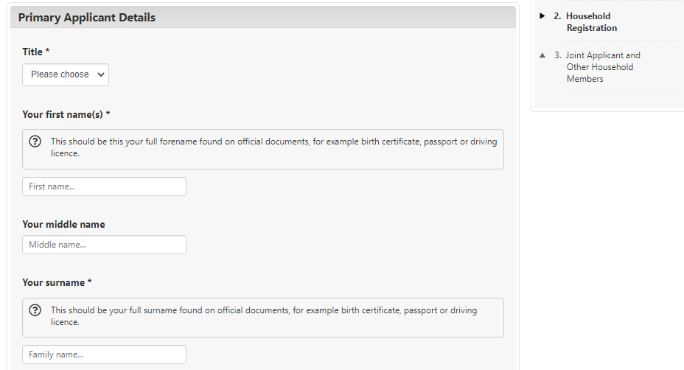

Step 4.
You can enter your postcode and then click on ‘Find address’ to choose your address from a dropdown list. If it doesn’t appear on the list, you can enter it manually.
Enter the date you moved into this address.
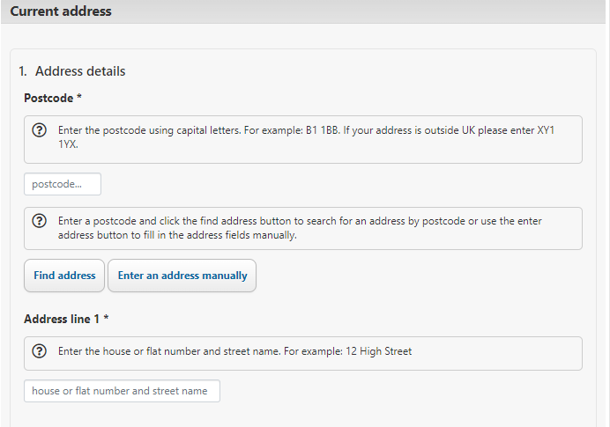

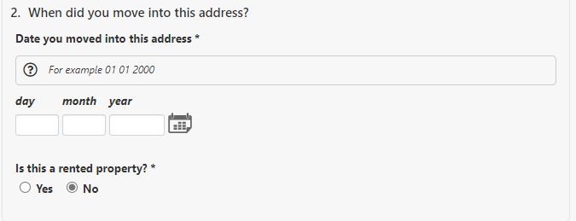
You will need to confirm when you have moved into an address. Addresses need to be supplied for the last 5 years.
You will need to inform us if you were placed there by another local authority.

Step 5.
You will then need to enter your contact details, including your email address.
We will contact you via email or by telephone; therefore, it is very important for you to keep your contact details up to date.
Once you have registered your household you can login and update your email and telephone contact details from your My Account page at any time.
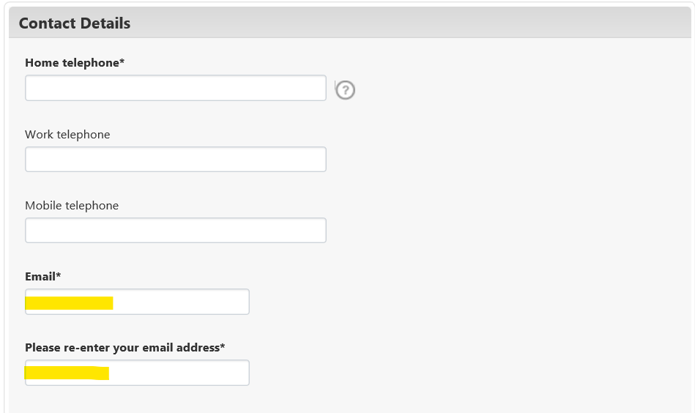

Step 6.
The next section is Equality and Diversity Monitoring.
We ask you to provide us with this information so that we can adequately monitor how we provide services for you.
All monitoring data is classified as personal data under the Data Protection Act and will be treated confidentially. We will only use this information for statistical purposes.
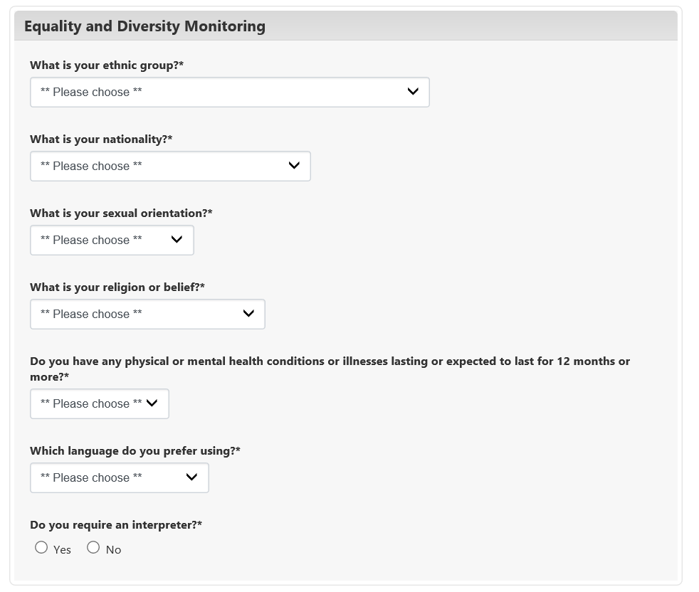

Step 7.
The next question is Eligibility to join the Council’s Housing Register.
The law states that the Council is not allowed to offer a home to certain people. Some people from abroad who don’t meet certain immigration and residence conditions won’t be eligible to join the housing register. These rules are complicated, so if you’re not sure whether you meet the conditions, seek advice.

Your current housing tenure is requested as eligibility provisions do not apply to most existing social housing tenants.
Please note that secondary questions will be asked when choosing several answers under Eligibility. The most common question we are asked is regarding what does CTA mean, CTA is a abbreviation for Common Travel Areas, more information regarding CTA can be found by clicking here.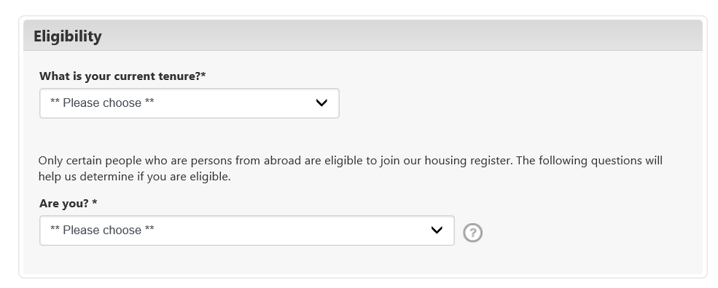

Step 8.
The next section is Local Connection. You may select more than one option. ‘None of the above’ should only be selected as an answer, if none of the listed options apply to your circumstances, it should not be selected alongside any of the other options.
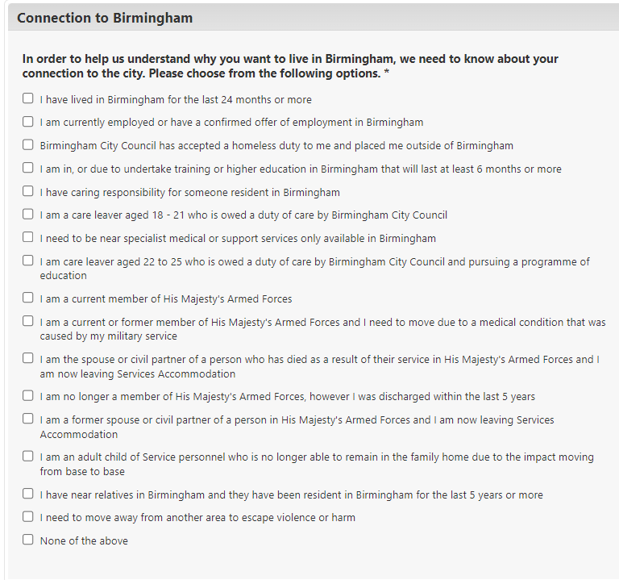

Step 9.
For security reasons customers are asked to add a memorable date.
This is used to log back into your account along with the password you create at this stage. There is validation against the password that you create. Passwords must be between 6 and 10 characters long and have at least 1 lower case letter, 1 upper case letter and 1 number. You cannot use symbols or punctuation.

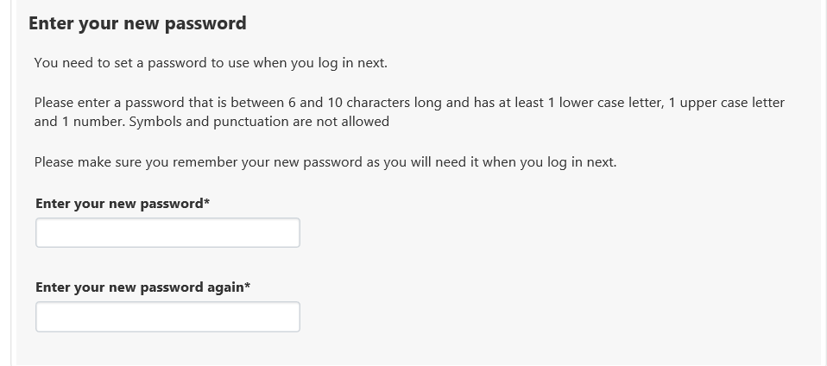

Step 10.
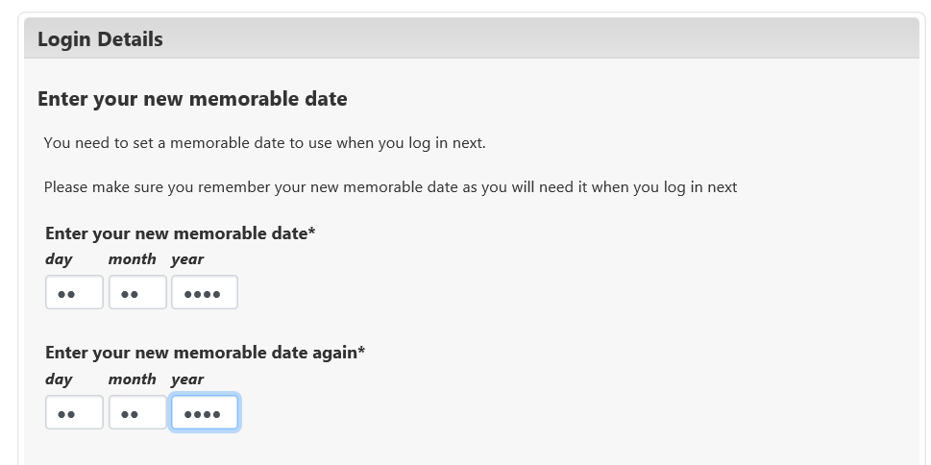

The screen will then display your login reference number Make sure you keep a note of your login reference number, memorable date, and password.

You will be asked you if you wish to add any additional household members. This is where you can add a joint applicant, those requiring rehousing with you, and any people you are currently living with.
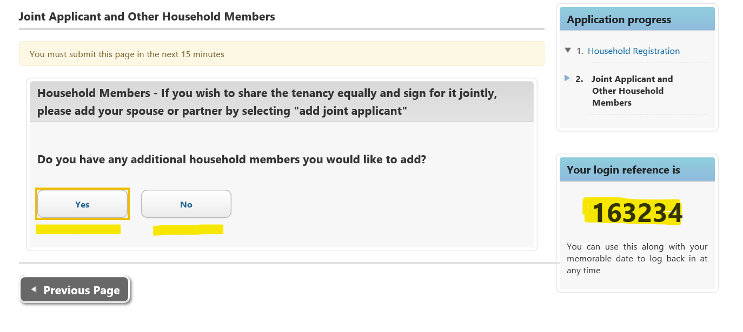
All persons added will be required to complete some of the main applicant questions.

You will be required to confirm:

• The relationship to the main applicant i.e. partner, son, daughter etc.
• If their address is different to the main applicant, enter the address detail, the date
they moved in and the reason why they live apart.

When you complete the page for each person click ‘Save Joint Member’ or ‘Save Additional Member’. You can then add another person or go to the ‘Next Page’.
After adding the last member to the household then select No and the screen will say that you have completed your registration with Abritas.

Please note, you have not applied for housing yet. Make a note of your login reference number and continue to the next section.

Applying for Social Housing

Section 1-3 Start an application.

Following the previous steps you have now registered your details and created a unique login reference with a memorable date and password. This will now enable you to complete an application for housing.
In order to complete an application for housing you must first select Apply for Social Housing

The first page you will see is the declaration, you will need to read through this before selecting you accept the declaration. If someone is completing the form on your behalf this will need to be indicated on the form:

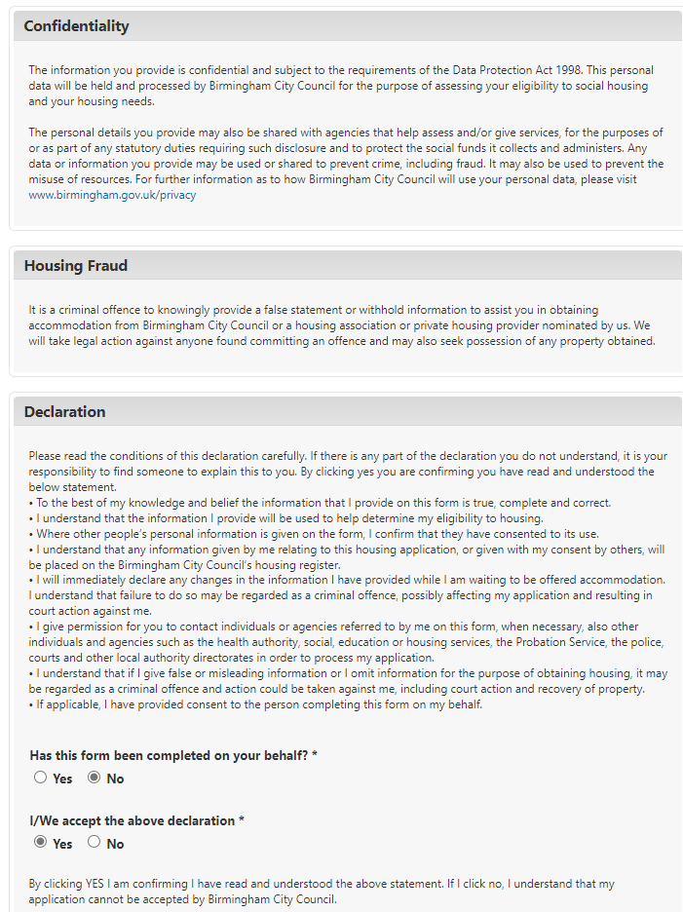
On the right you will see the stages required to complete an application for housing. There are 15 steps, and you have already completed the first 3 when you registered an account on Birmingham Choice.
If the system logs you out, your progress is saved, and you will be able to continue from the point you previously got to.
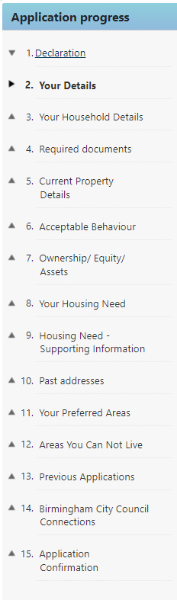

Section 4 Uploading documents

At this stage you will be requested to submit certain documents to evidence your eligibility to join the housing register and for any other household member who may become a joint tenant for e.g. passport, driving licence, utility bill, bank statements etc.
You can also upload supporting documentation for your housing circumstances i.e. medical practitioners report, environmental health officer report etc.
If this information is not available to you at the time of completing the application, you will still be able to proceed with the remainder of the form and submit the application for assessment. However, you will need to upload the required documentation soon after submission.

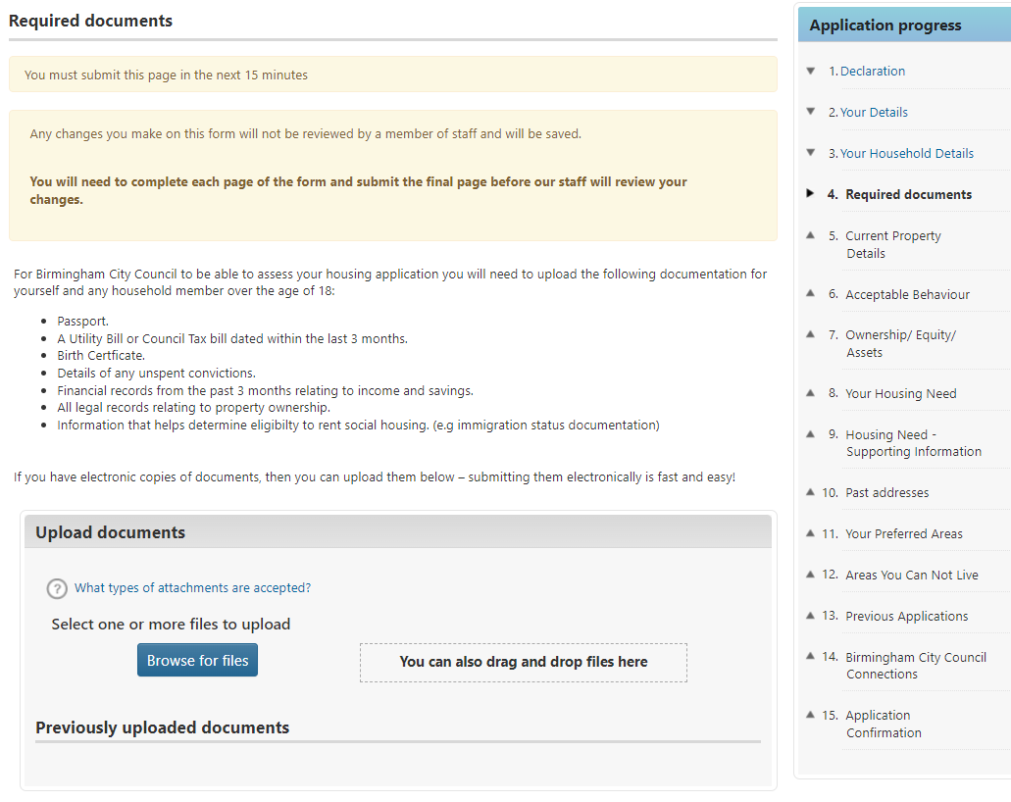

Section 5 Current Property Details

By answering the questions, we will be able to calculate, for example, the number of people in your household and whether you are currently overcrowded or under-occupying social housing.

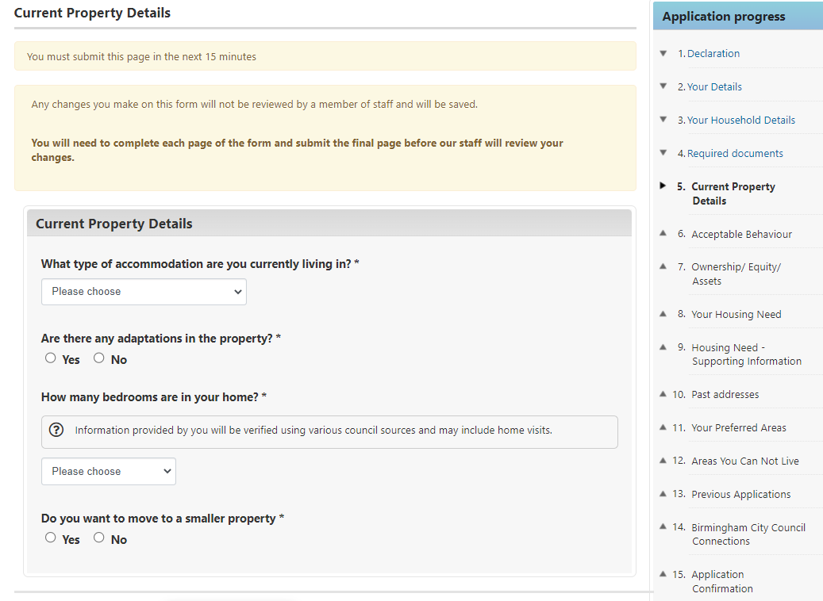

Section 6 Acceptable Behaviour

In this section you will be asked about your conduct and the conduct of your household members. Any areas that you have ticked yes to will require you to provide further details in order for us to assess whether you qualify to join the housing register.

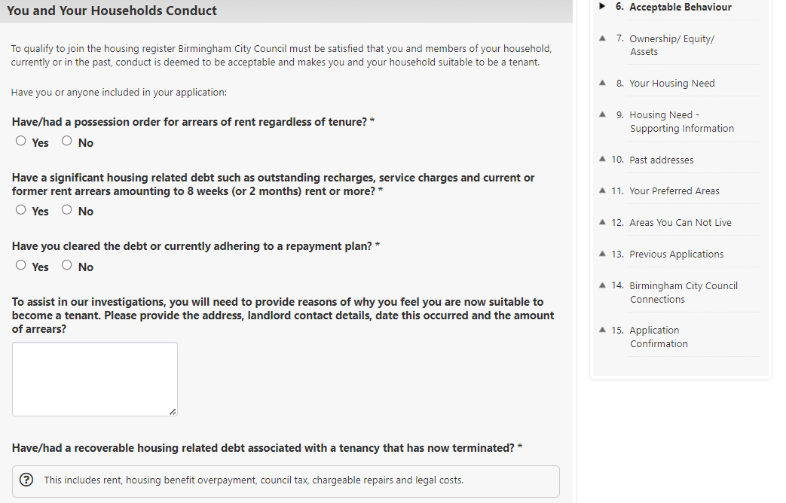

Section 7 Ownership/ Equity/ Assets

There is a threshold of income or assets which may mean you and your household can satisfy your own housing needs. This includes any value of property you or your household have a financial interest in, and any savings or stock you or they have. If there are exceptional circumstances which mean you are unable to reside in the property you own or have a financial interest in, you will also be able to notify us of this in this section.
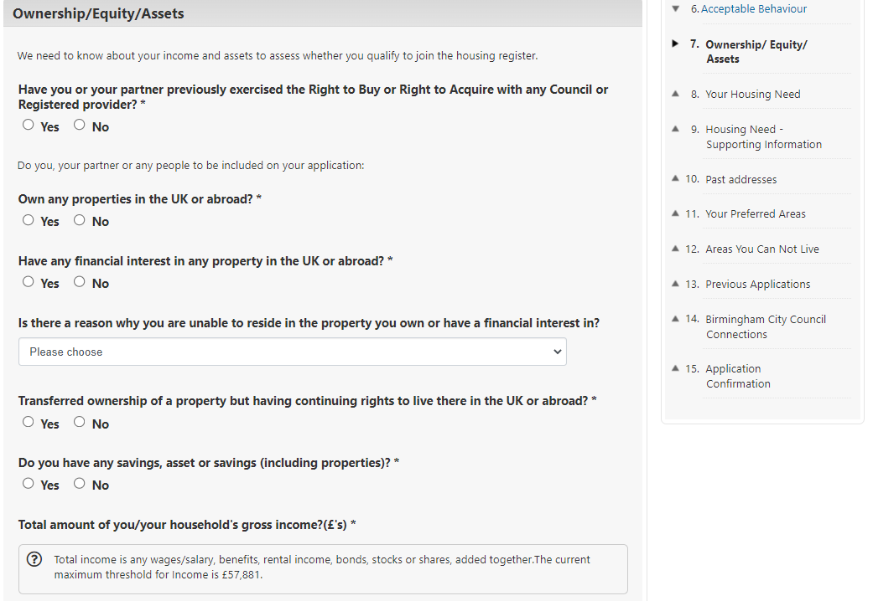

*Please be careful in this income section that you enter your income correctly and then select the correct frequency of that amount.

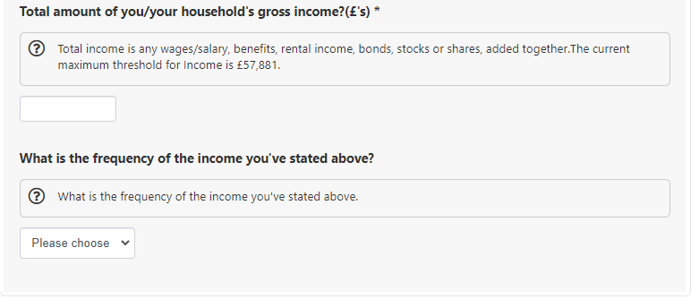

Section 8 Your Housing Need

This section asks you why you are applying for housing, and depending on your answer, may require you to input further information to support this.
Ticking the option ‘None of the above’ will indicate that you have No Housing Need and unlikely to qualify to join the housing register..
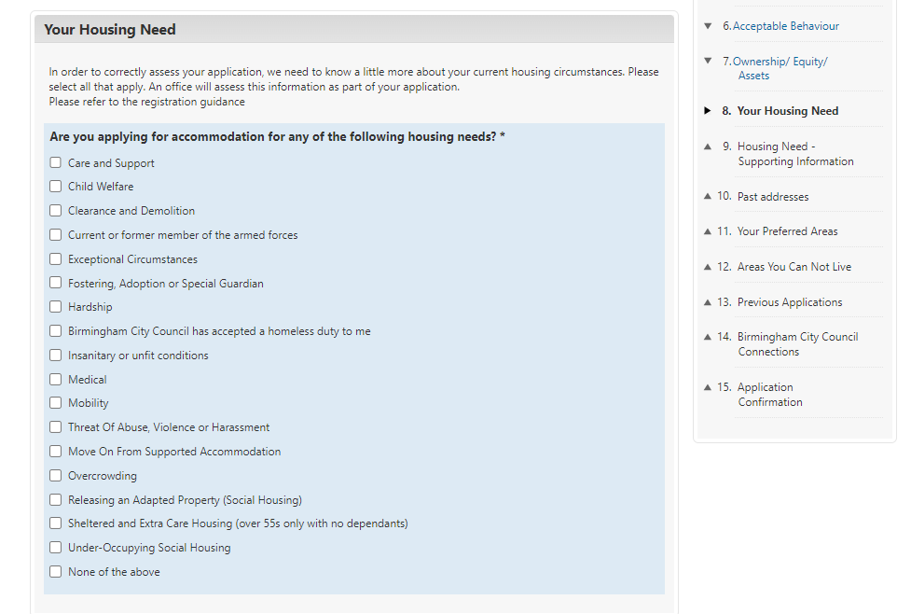

Section 9 Housing Need – Supporting Information

This section needs to be completed where further information is required for the housing needs selected.

Section 10 Past Addresses

This section only needs to be completed if you have not lived at your address for the past 5 years.

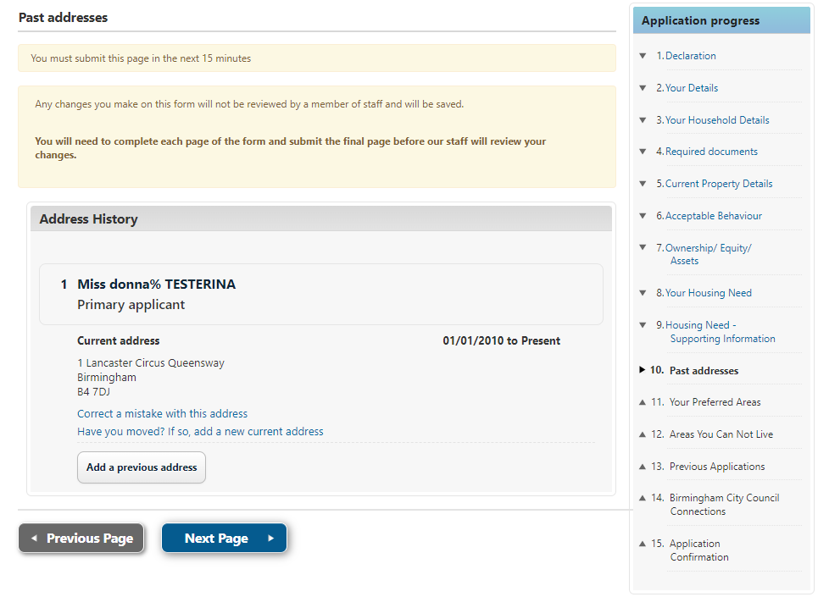

Moving in and out dates must not overlap. You cannot enter any date in the future.

Section 11 Preferred Areas

This section covers the preferred areas of Birmingham you would like to live. You will need to select ‘browse for locations’ to see a list of Birmingham Wards and Areas that you can select.

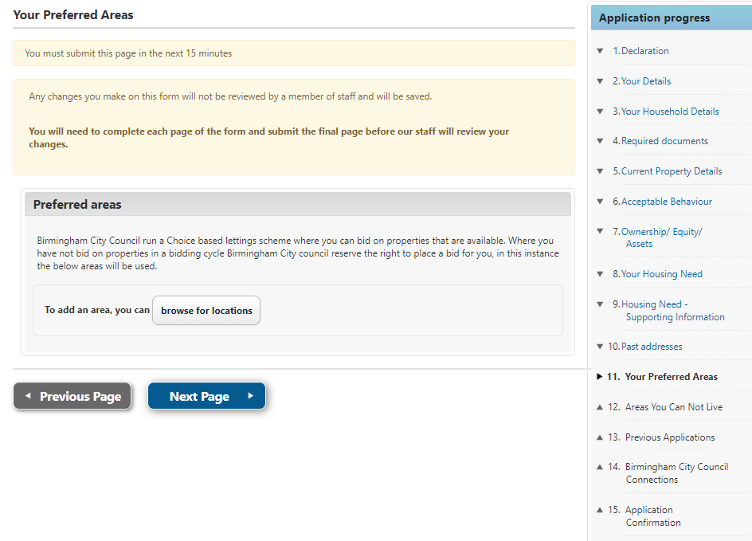

You can choose as many areas of preference as you wish but you must select at least one to proceed with the remainder of the form.

Section 12 Areas you cannot live

You do not have to select any area unless you are at risk in a particular location. Due to the limited amount of housing stock, you are advised to only select areas you cannot live in due to a risk that area may pose, rather than areas you do not prefer to live in.
If you are accepted onto the housing register you will not see any properties you are eligible to bid for in the excluded areas, you have selected.

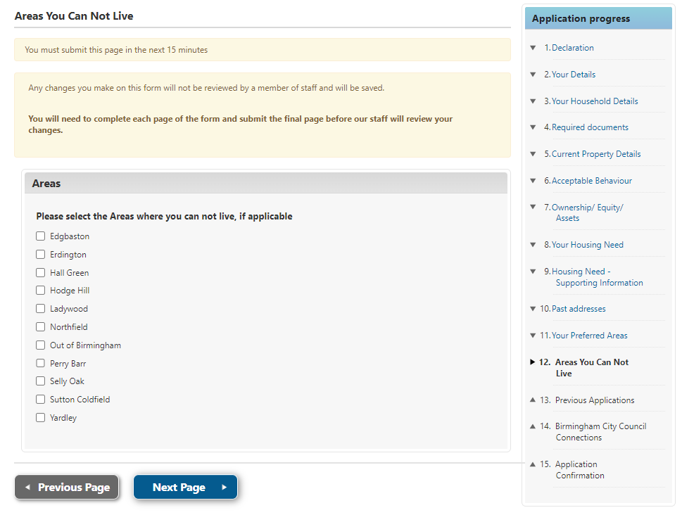

Section 13 Previous Applications

You will be asked if you have previously applied for housing with Birmingham City Council. If so, please add the details.

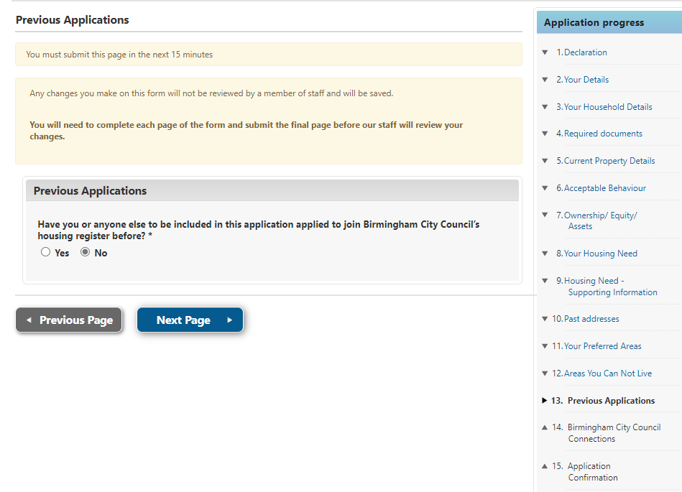

Section 14 Birmingham City Council Connections

You must tell us if you or any members of your family are connected to any employees or Councillors of Birmingham City Council.
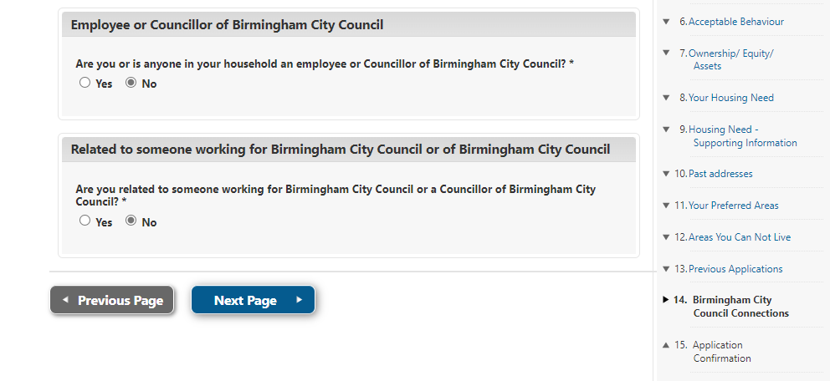

Section 15 Application Confirmation

This final section allows you to submit your application for processing. You can also go to previous sections if you wish to check or change any of your answers.
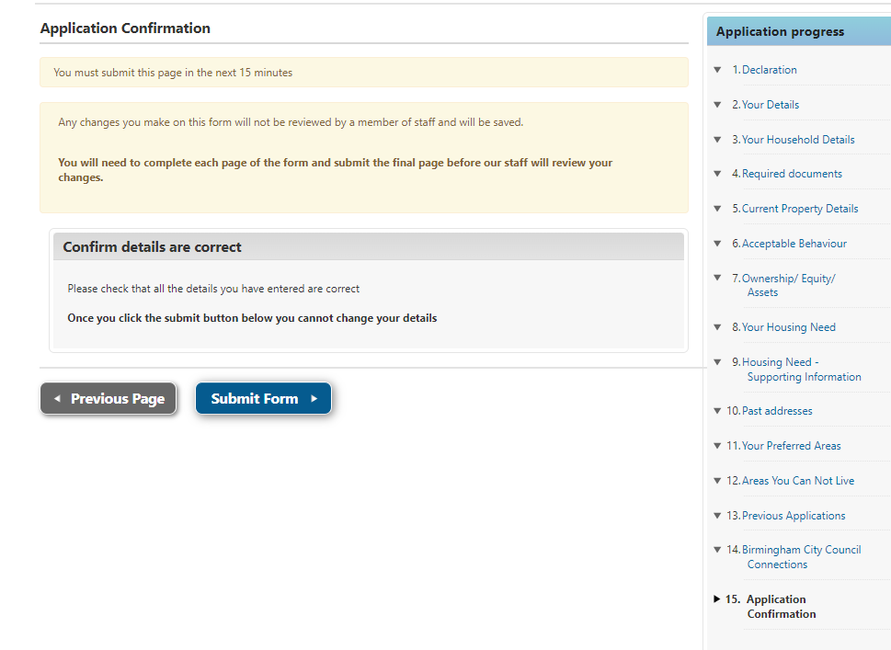
Once submitted you will not be able to change your application details until the assessment has been completed.
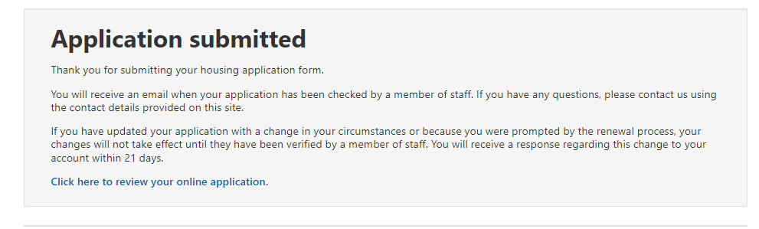
Application forms submitted will be assessed in date order of receipt, from the earliest received first.
During the assessment an officer may contact you to discuss further details of your application or request further information to support it. You will be able to add information this by logging into your account and selecting Upload / Review documents:

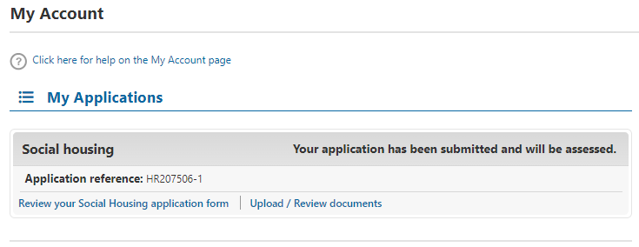

Change in circumstances for existing applicants

If you are already registered and your application is active, but you need to tell us about a change in circumstances, you need to log in to your online account and update your application form with the changes. This will ensure that your application is up to date and that you can bid for suitable properties which meet your needs and have been awarded the right level of priority.

Please ensure that you go to the last page of the form and press submit once you have made the relevant changes to your application.

Your application will not be suspended whilst we are reassessing your application. We will email you to request any extra information or documentation required to support your changes and you must provide this within the stated timescale or your application will be cancelled.

Examples of changes of circumstances are detailed below, although this list is not exhaustive:

• You change your address
• Someone in your household has moved in or out your home
• You want to add or remove a family member to your application e.g. birth of a child
• Change of medical circumstances of any household member
• Death of a joint applicant or household member
• Any other circumstances that may materially affect your application

